Visualize the RSI
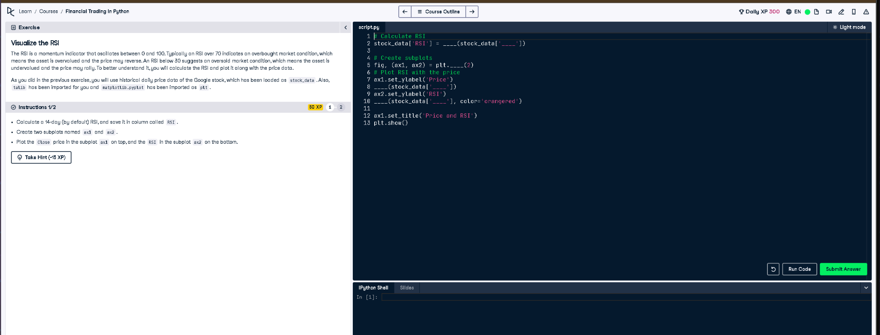

Full Python Code
# Calculate RSI
stock_data['RSI'] = talib.RSI(stock_data['Close'])
# Create subplots
fig, (ax1, ax2) = plt.subplots(2)
# Plot RSI with the price
ax1.set_ylabel('Price')
ax1.plot(stock_data['Close'])
ax2.set_ylabel('RSI')
ax2.plot(stock_data['RSI'], color='orangered')
ax1.set_title('Price and RSI')
plt.show()

Simple Explanation (50 Words)
This code calculates the 14-day RSI using talib from the stock’s closing prices. It then creates two subplots: one showing the price and another showing the RSI. RSI values help identify when a stock may be overbought or oversold, giving traders insight into possible trend reversals.

